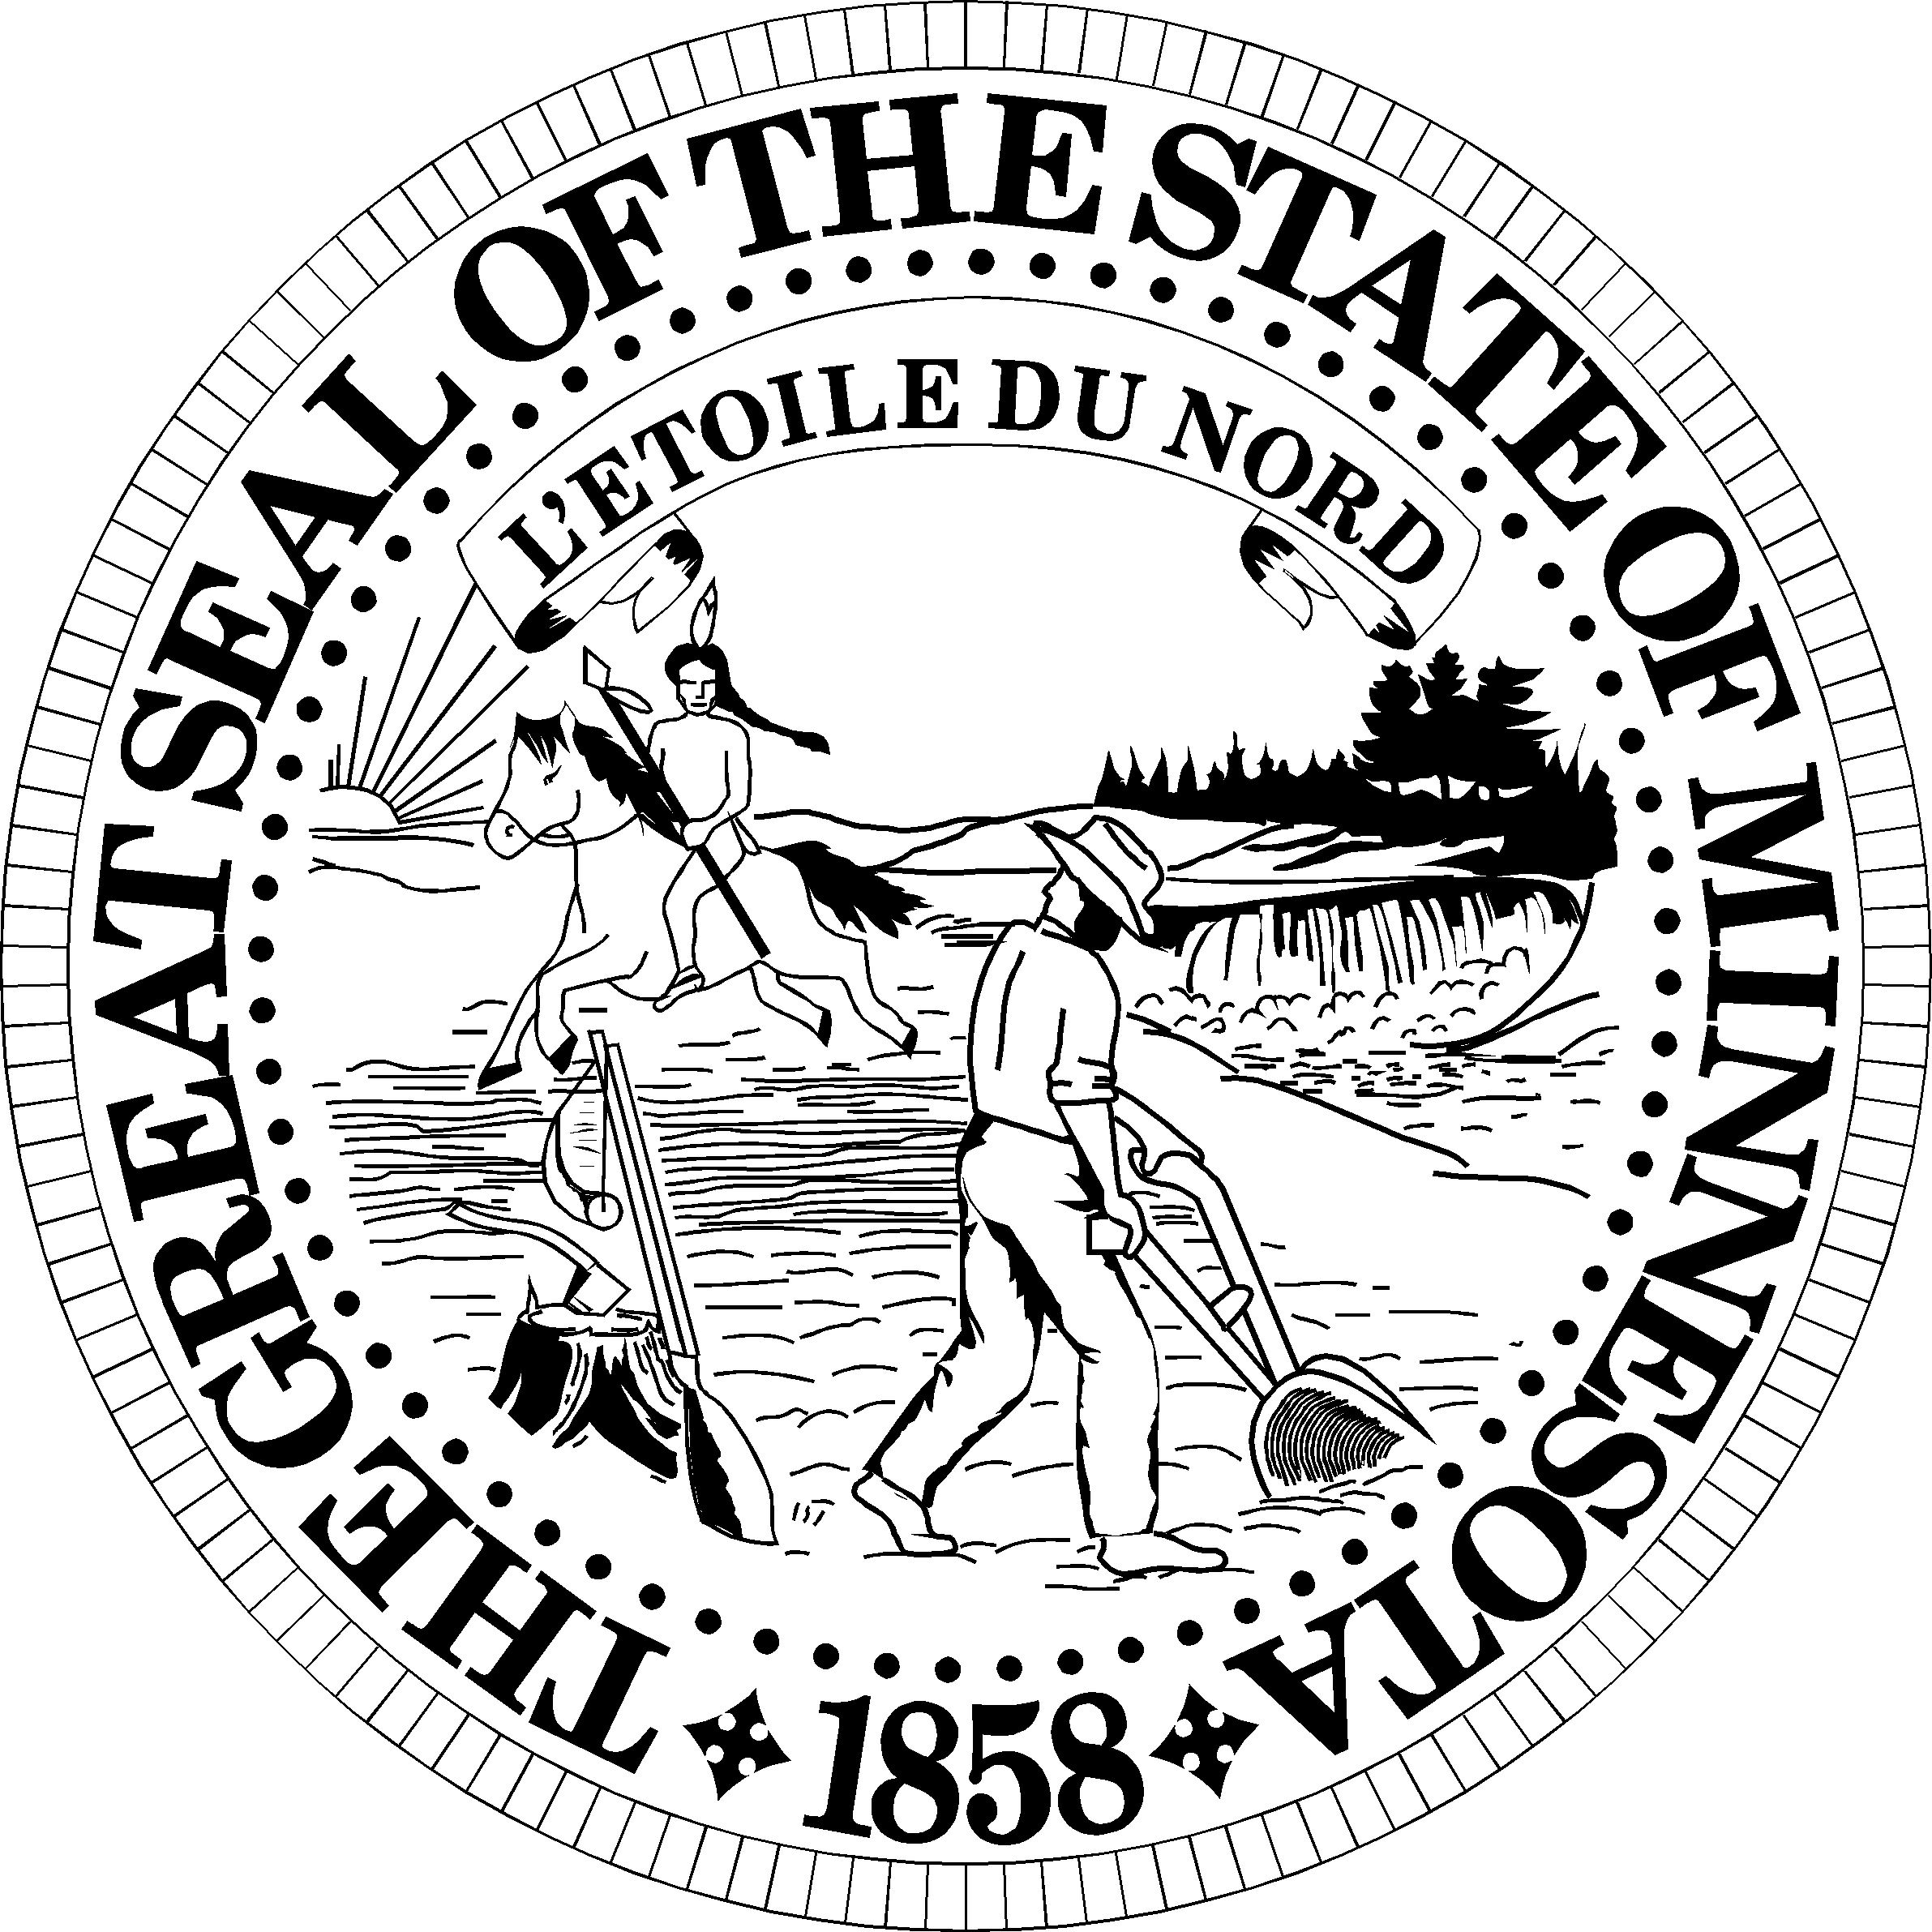

**Noah Shadis**

Senior Purchaser & Accounting Officer

Office of Governor Tim Walz & Lt. Governor Peggy Flanagan

130 State Capitol

Saint Paul, Minnesota 55155

[Noah.Shadis@state.mn.us](mailto:Noah.Shadis@state.mn.us)

<http://mn.gov/governor>

Phone: (651) 201-3448

Fax: (651) 797-1883

Minnesota Relay (800) 627-3529